Grade 7 Accelerated · Unit 4 · Lesson 1  Adding and Subtracting in Scientific Notation  Independent Set 4.01 ANSWER KEY | Name  Date  Period

Six questions, on your own, in silence. Show the step that does the work.
1. 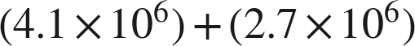
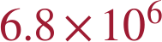

2.
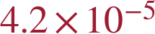

3. 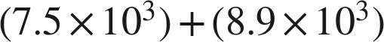

The sum is 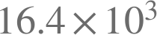, which is not finished.

4. 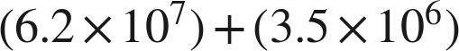

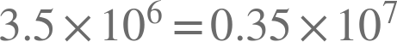.

5.
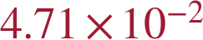
.

6. Find .
n = 7.9
.

